𝗗𝗮𝘁𝗮𝗯𝗮𝘀𝗲 𝗧𝗶𝗽 #𝟮 -- 𝗛𝗼𝘄 𝘁𝗵𝗲 𝗢𝗽𝘁𝗶𝗺𝗶𝘇𝗲𝗿 𝗨𝘀𝗲𝘀 𝗜𝗻𝗱𝗲𝘅𝗲𝘀
Understanding why a database optimizer chooses an index seek in some cases and a full scan in others is one of the most important mental models in query tuning. Yet it’s also one of the most misunderstood. Many people assume seeks are always “good” and scans are always “bad,” but the optimizer is far more strategic than that.
At the heart of every access-path decision is a single idea: how much of the table the query is expected to touch. Once you understand that, the optimizer’s behavior becomes predictable — and tuning becomes easier.
In this post, I break down the seek-vs-scan decision flow in a clear, visual way so you can see exactly how the optimizer thinks.
When a query includes a filter, the optimizer must choose the most efficient way to retrieve the required rows. That choice almost always comes down to two access paths:
- Use an index seek to jump directly to matching rows, or
- Perform a table or index scan to read pages sequentially.
The optimizer makes this decision using a simple but powerful concept: selectivity — how many rows the filter is expected to return.
To understand how this works, here’s a clear, step-by-step decision flow that mirrors the optimizer’s logic.

𝗢𝗽𝘁𝗶𝗺𝗶𝘇𝗲𝗿 𝗗𝗲𝗰𝗶𝘀𝗶𝗼𝗻 𝗙𝗹𝗼𝘄: 𝗦𝗲𝗲𝗸 𝗼𝗿 𝗦𝗰𝗮𝗻?
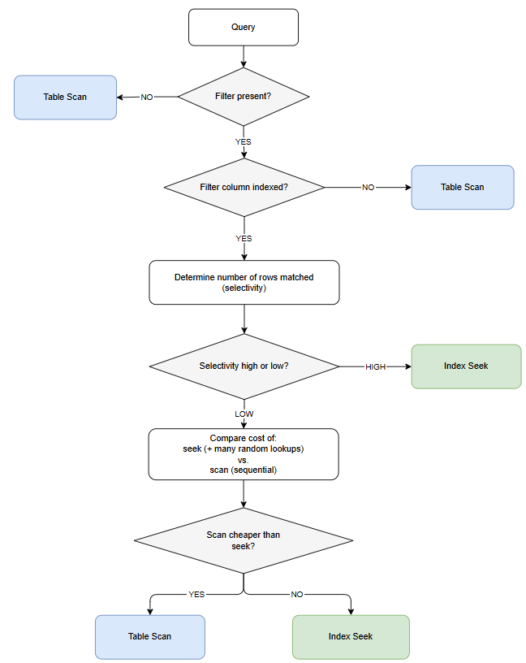
𝗡𝗼𝘁𝗲:This diagram shows the optimizer’s behavior when evaluating a single filter condition. With multiple predicates, the optimizer considers each indexed column, their combined selectivity, and whether composite indexes exist.

𝗨𝗻𝗱𝗲𝗿𝘀𝘁𝗮𝗻𝗱𝗶𝗻𝗴 𝗦𝗲𝗹𝗲𝗰𝘁𝗶𝘃𝗶𝘁𝘆
Selectivity determines whether the index is helpful:
- High selectivity: the filter returns a small percentage of the table
- Low selectivity: the filter returns a large percentage of the table
And importantly…if the query has no filter at all, the optimizer must read the entire table — which always results in a scan, regardless of the table’s size.
On small tables, this is fast.
On large tables, it can be expensive — but still cheaper than using an index when all rows are needed.
𝗪𝗵𝘆 𝗦𝗰𝗮𝗻𝘀 𝗔𝗿𝗲𝗻’𝘁 𝗔𝗹𝘄𝗮𝘆𝘀 “𝗕𝗮𝗱”
A scan simply means: “Read all data pages sequentially in storage order.”
Sequential I/O is extremely efficient as the DBMS reads large amounts of data with minimal overhead, which is why scans can outperform seeks when many rows are needed.
And here’s the key nuance: whether a scan is “fast” or “slow” is relative to the size of the table.
• On small tables, scanning every page is often faster than seeking into an index.
• On large tables, a scan can be expensive — but still cheaper than performing thousands or millions of random lookups when many rows are needed.
Indexes help only when they allow the optimizer to avoid reading non-qualifying data. If most of the table must be read anyway, the index provides no benefit.
𝗧𝗮𝗸𝗲𝗮𝘄𝗮𝘆
Indexes improve performance by reducing the amount of data the DBMS must read.
If the filter is highly selective, a seek is efficient.
If the filter returns many rows — or there’s no filter at all — a scan becomes the cheapest option.

